Leviticus
Sanctification through Sacrifice and Separation

Purpose: that the LORD might be able to remain with the nation

Place: Mount Sinai

Time: One Month

Chapters 1–10 |  |  |  |  |  |  | Chapters 11–27
Sacrifice |  |  |  |  |  |  | Separation
Worshipping a Holy God |  |  |  |  |  |  | Walking with a Holy God
Securing Fellowship with God |  |  |  |  |  |  | Continuing Fellowship with God
Approaching God |  |  |  |  |  |  | Appeasing God
Perfect Sacrifices  (1–7) |  |  | Perfect Priests  (8–10) |  |  |  | Laws of Sanctification for…  (11–27)
Uncleanness  (11–15) | Unintentional Sin (16) |  |  | Tabernacle  (17) | Crimes  (18–20) |  |  | Priests  (21–22) | Worship  (23–24) |  | Canaan  (25–26) | Vows  (27)

Key Word: Sanctification (Holiness)

Key Verse: “I am the LORD your God; consecrate yourselves and be holy, because I am holy… I am the LORD who brought you up out of Egypt to be your God; therefore be holy, because I am holy” (Leviticus 11:44-45; repeated in 19:2; 20:7, 26)

Summary Statement:
The way Israel could continue to enjoy God’s presence was by obeying God’s laws of sanctification through sacrifice and separation.

Application:
We as believers need to continually separate (sanctify) ourselves by confessing our sin and walking in holiness before God in order to experience His presence with us.

For Further Study:
John S. Feinberg defends the issue of how OT sacrifices actually forgave sin in his chapter “Salvation in the Old Testament,” in Tradition and Testament: Essays in Honor of Charles Lee Feinberg, eds. John S. and Paul D. Feinberg (Chicago: Moody, 1981), 39-77 (esp. 59-75). See also my OT Survey, 119e summary of this chapter.

Leviticus

Introduction

I. Title Leviticus may seem a strange title since the book mainly has priestly ceremonies and institutions, whereas the Levites are mentioned only once (25:32). However, since Aaronic priests were from the tribe of Levi and the sacrificial system that they administered was commonly called Levitical, this title is justified (Lindsey, BKC, 1:163). The Hebrew title is simply "And He Called" (ar;q.YIw: wayyiqra) from the first word (1:1).

II. Authorship

A. External Evidence: Ancient writers consistently refer to Moses as the author of Leviticus. Christ Himself held to this tradition as he referred to the leprosy law of cleansing (Lev. 14:2-32) as written by Moses (Matt. 8:4; Mark 1:44).

B. Internal Evidence: Leviticus does not give its author, but the first word continues the story from Exodus, which does claim Mosaic authorship (Exod. 17:14; 24:4, 7; 34:27-28; cf. Deut. 31:9, 24). Also, as its contents were revealed to Moses at Sinai (7:37-38; 26:46; 27:34) it makes sense that he is the one who recorded them here. The book also shows a consistent style expected of a single author.

III. Circumstances

A. Date: Mosaic authorship places the writing in his lifetime (1525-1405 BC). Since the tabernacle was set up exactly one year after the Exodus (Exod. 40:17) and the Book of Numbers resumes one month later (Num. 1:1), the intervening Book of Leviticus must cover only one month (in 1444 BC). Moses probably recorded these laws shortly after they were given in 1444 BC.

B. Recipients: Moses died before Israel entered the Promised Land so the original readers comprised the Jews in the wilderness with him.

C. Occasion: Exodus 25–27 and 35–40 records Israel building the tabernacle to use in the nation’s worship. However, while the people had all the equipment, they still did not know how to conduct tabernacle worship. Leviticus fills in this gap. Moses knew that he would soon die but the nation would live on for generations, so he wisely and under the direction of the Spirit recorded the specific regulations in Leviticus as a written record of God's will for the worship and walk of the new nation.

IV. Characteristics

A. "The Book of Leviticus was the first book to be studied by a Jewish child; yet it is often among the last books of the Bible to be studied by a Christian. However, a book referred to about 40 times in the New Testament should be of great significance to every Christian" (Lindsey, BKC, 1:163).

B. Leviticus has more information on the Mosaic sacrificial system than any book in Scripture and gives the background needed to understand the Book of Hebrews in the New Testament.

Argument

Leviticus teaches two ways to remain holy, or be “set apart” (sanctified) for the new nation of Israel so that the people might be holy as God is holy (11:45). These two means appear in both major parts of the book, but sacrifices are more prominent in the first half (chs. 1–10) and separation from the pagan practices of Israel's neighbors occupy the major thrust in the latter half (chs. 11–27). The reason the nation needs to be sanctified is because God's presence cannot dwell with a wicked people.

Synthesis

Sanctification through sacrifice and separation

1–10 Sacrifice (worshipping God)
1–7 Five offerings
1:1–6:7 General instructions for the people
1–3 Consecration/voluntary: burnt, grain, fellowship
4:1–6:7 Cleansing/obligatory: sin, guilt
6:8–7:38 Specific instructions for the priests
8–10 Proper priestly service
8 Ordination of Aaron
9 Sacrifices begin
10 Unauthorized practice—death

11–27 Separation (walking with God)
11–15 Uncleanness
11 Animals
12 Childbirth
13–14 Leprosy (skin/mildew)
15 Discharges
16 Day of Atonement
17 Tabernacle/Blood
18–20 Crimes
18 Sexual
19 Social
20 Capital
21–22 Priestly restrictions
21 Personal
22 Sacrificial
23–24 Worship
23 Feasts
24:1-9 Daily oil/weekly bread
24:10-23 Death for blasphemer/murderer
25–26 Canaan
25 Special years (Sabbatical, Jubilee)
26 Blessings and curses
27 Vows

Outline

Summary Statement for the Book
The way Israel could continue to enjoy God’s presence was by obeying God’s laws of sanctification through sacrifice and separation.

The way Israel could continue to enjoy God’s presence was by obeying God’s laws of sanctification through sacrifice (Lev 1–10).

Sacrifices to worship God and gain temporal cleansing kept God's presence with the nation (Lev 1–7).

General sacrificial information shows the people how to offer sacrifices when both in and out of fellowship with God (1:1–6:7).

Sacrifices for consecration show Israel how to worship God when in fellowship (Lev 1–3).

The burnt offering is a voluntary sacrifice that totally consumes the animal to draw near to God in total dedication (Lev 1).

The grain (meal) offering is a voluntary, auxiliary, bloodless offering to show thanks to God for his provisional care (Lev 2).

The fellowship (peace) offering is a voluntary family meal to worship God (Lev 3; cf. 7:12-16).

Sacrifices for cleansing show how to approach God when out of fellowship (4:1–6:7).

The sin offering is an obligatory sacrifice to atone (i.e., appease God's wrath) for unintentional sins (4:1–5:13).

The guilt (trespass) offering is an obligatory sacrifice to make restitution for withholding proper due from God or man (5:14–6:7).

Specific sacrificial information gives the priests administrative details how to offer the preceding offerings by showing which persons, places, and portions God accepted (6:8–7:38).

The establishing of the priesthood enabled God's presence to remain with the nation (Lev 8–10).

Aaron and his sons are ordained as representatives of God for the people (Lev 8).

Sacrifices begin to show God’s God's blessing on the priests and institution (Lev 9).

Nadab and Abihu die to show the severe results of abusing God’s sacrifices (Lev 10).

The way Israel could continue to enjoy God’s presence was by obeying God’s laws of sanctification through separation from pagan practices (Lev 11–27).

Unclean practices of pagans are given to make a holy people of God who can worship him acceptably so that his presence might remain with the nation (Lev 11–15).

For some amazing ways that God protected Israel from diseases by obeying these precepts, see S. I. McMillen, None of These Diseases (Old Tappan, NJ: Revell, 1963, 1984; revised, updated & expanded, Singapore: Aenon Int’l & ValuPrint, 1997) and p. 131 of these notes.

Clean and unclean animals are identified so Israel can separate from pagan practices of neighbors as a holy people of God so that his presence might remain with the nation (Lev 11).

Childbirth regulations note that postnatal discharges render a woman unclean for bringing a sinner into the world, so she must wait a period of time before worshipping acceptably (Lev 12).

Infections and mildew regulations are deemed unclean to prevent advanced leprosy so that the nation's worship of God might not be disrupted (Lev 13–14).

Discharges for men and women show a lack of wholeness required for acceptable worship (Lev 15).

The Day of Atonement to cleanse the sanctuary from the pollution of the nation's unintentional sin makes possible God's continued presence among his people (Lev 16).

Sacrifice is limited to the tabernacle and eating blood is forbidden so that Israel will not identify with the practices of pagan neighbors (Lev 17).

Crimes in the sexual and social realms appear with capital crimes to prevent Israel from imitating pagan practices for God's presence to abide with the people (Lev 18–20).

Laws restricting sexual relations protect Israel’s marriage and family life in contrast to the destructive practices of Egypt and Canaan (Lev 18).

Laws of the social order promote practical holiness within Israel so that God's sovereign and holy presence might abide with the people (Lev 19).

Laws requiring capital punishment (except 20:19-21) denote the gravest religious and family sins to rid the community of pagan influences (Lev 20).

Priestly restrictions uphold a higher standard to prevent God's name from being profaned (Lev 21–22).

Personal restrictions for priests about mourning, marriage, and physical defects hold a higher standard of holiness than for the common people (Lev 21).

Sacrificial restrictions for priests eating sacred offerings and offering of unacceptable sacrifices hold them accountable not to profane God's name by misusing offerings (Lev 22).

Worship commands fulfill conditions for God's presence to remain with the nation (Lev 23–24).

Feasts in the annual calendar remind Israelites to worship God together as a nation and recall his mighty deeds on their behalf (Lev 23).

Laws of daily oil and weekly bread for Israel's worship fulfill conditions for God's presence to remain with the nation (24:1-9).

Capital punishment for blasphemers and murderers apply laws to specific situations (24:10-23).

Canaan laws of special years and exhortations to obedience showed Israel how to be blessed rather than cursed (Lev 25–26).

Laws of special years place all Israelites on equal social level in food and land usage to remind them that they serve as tenants of a land that is really God's (Lev 25).

The Sabbatical Year prohibits farming every seventh year to place landowners and those owning no land on equal level by allowing all to eat any produce (25:1-7).

The Year of Jubilee allows reacquisition of land formerly deeded away to remind Israel that the nation serves as tenants of land that is really God's (25:8-55).

Blessings for obedience and curses for disobedience encourage Israel to obey the covenant (Lev 26).

Blessings for obedience show Israel the benefits of obeying the covenant (26:1-13).

Curses for disobedience show Israel the penalties of disobeying the covenant (26:14-46).

Vow laws cite allowed and prohibited articles to dedicate to the LORD to prevent rash vows (Lev 27).

Consecrating allowable things such as persons, animals, houses, and lands must be at extremely expensive prices to discourage rash vows (27:1-25).

Prohibiting firstborn animals, devoted things, and tithes from being consecrated prevents trying to "give" God what is already his (27:26-33).

The Bible and Blood

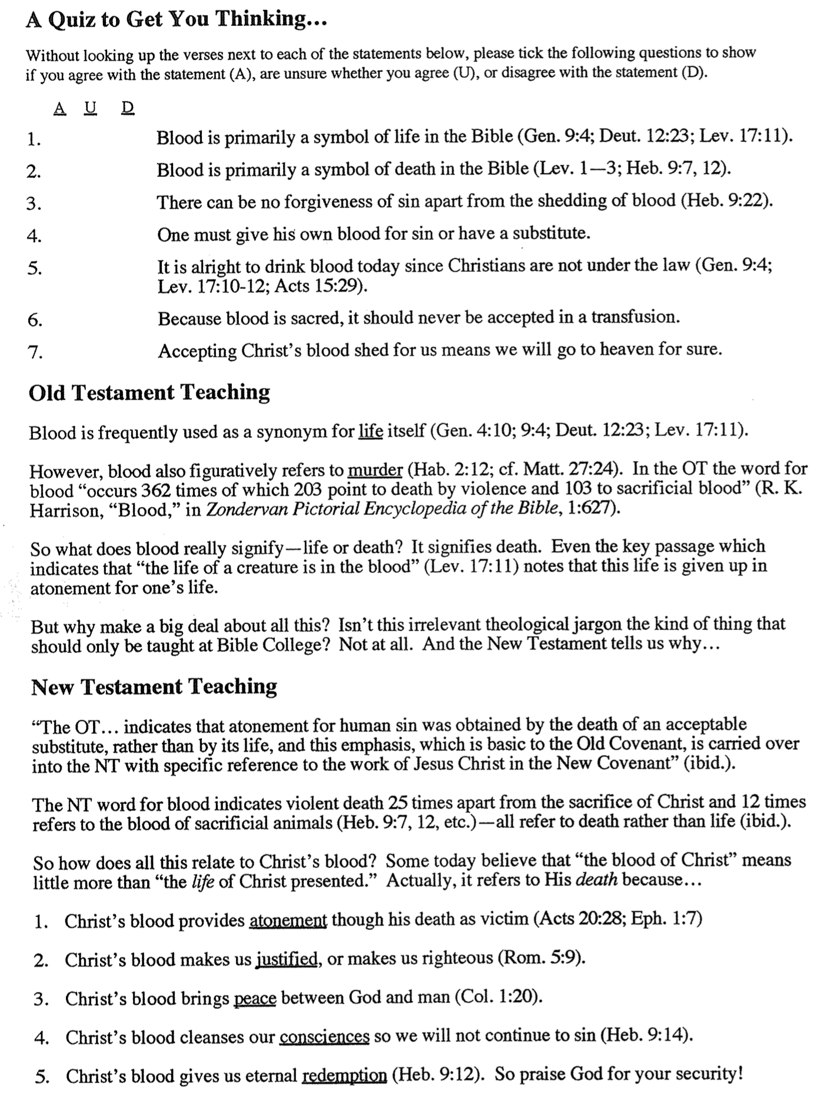

Old Testament Sacrifices
The Bible Visual Resource Book, 29

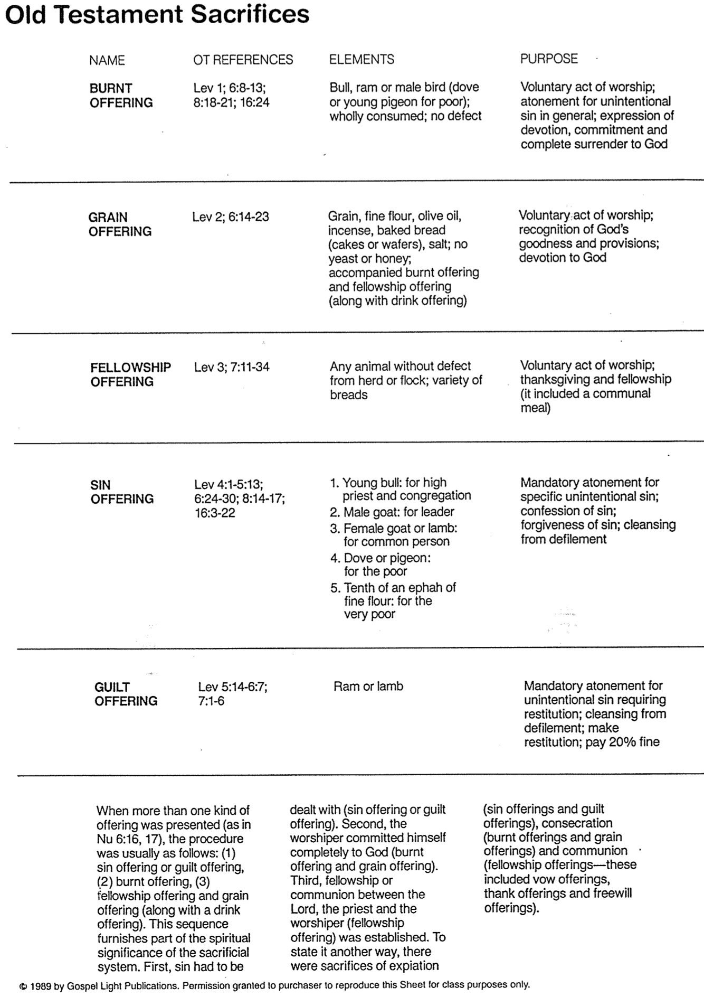

Rituals for Levitical Offerings
F. Duane Lindsey, “Leviticus,” The Bible Knowledge Commentary, 1:168-69

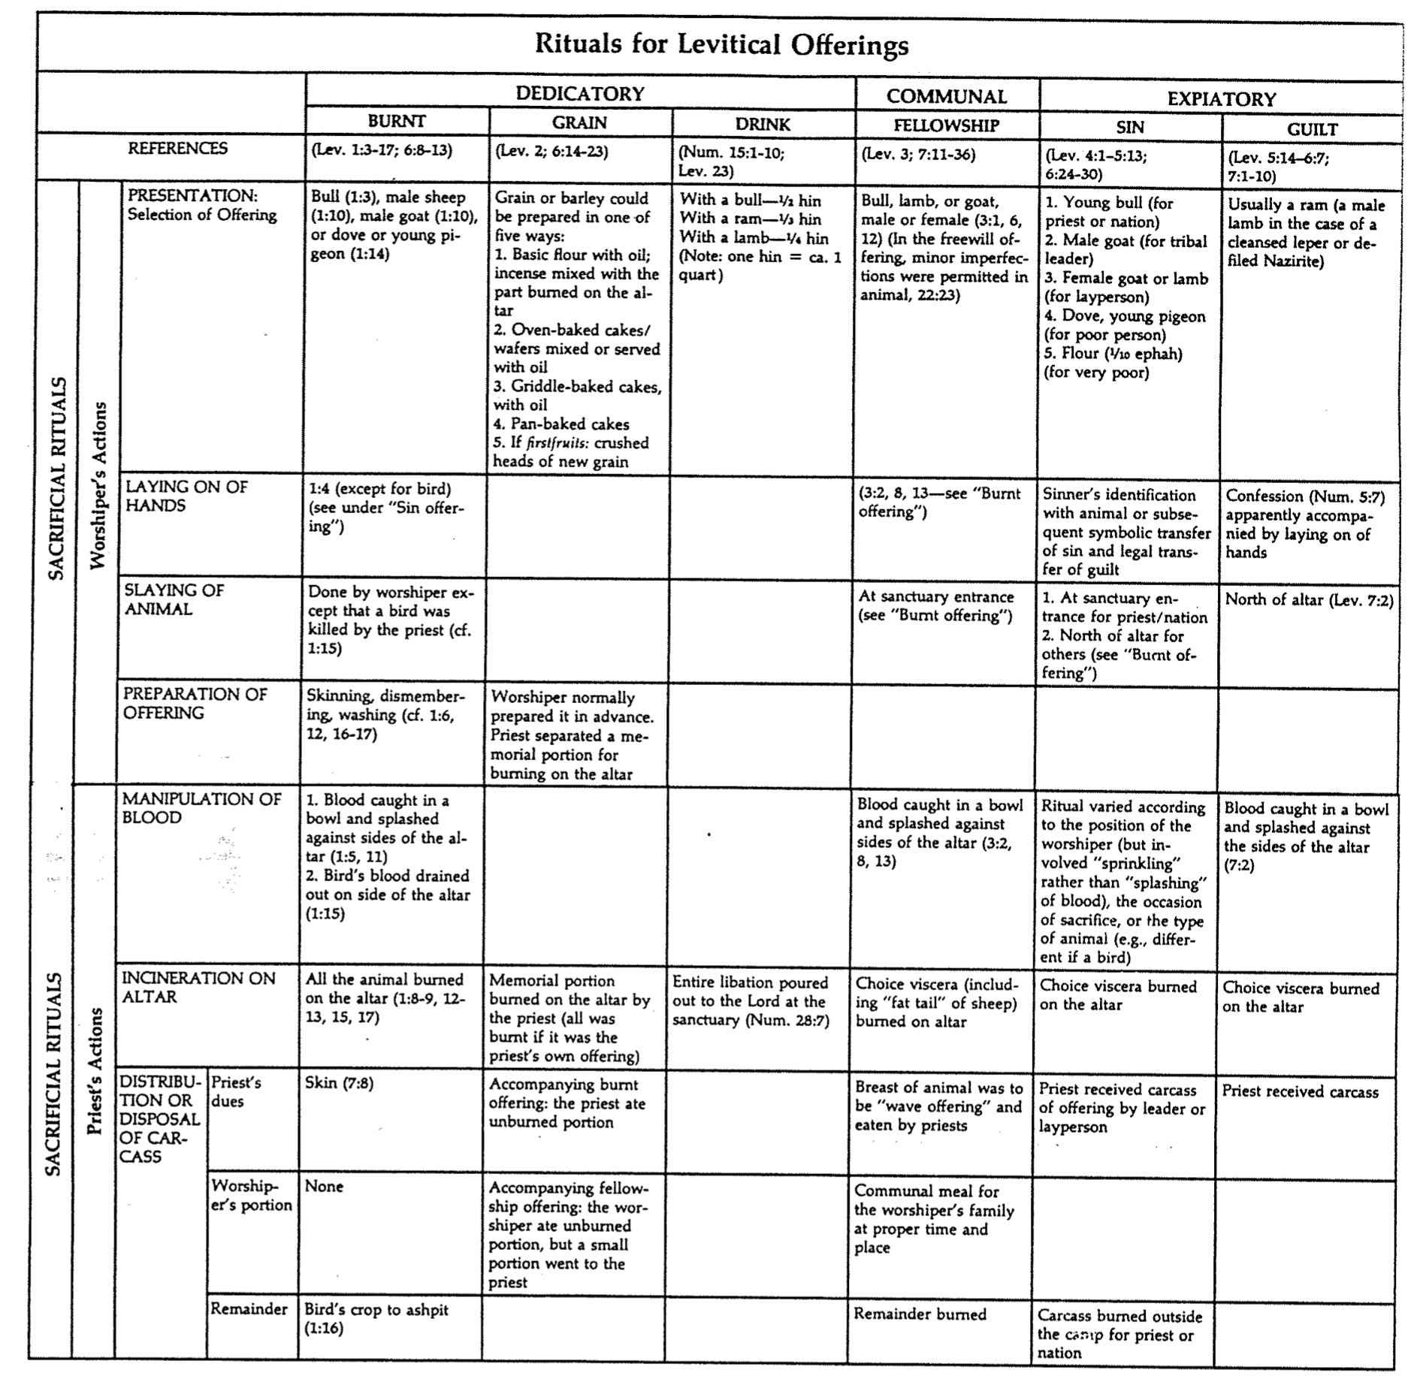

Special Sacrificial Rituals
F. Duane Lindsey, “Leviticus,” The Bible Knowledge Commentary, 1:168-69

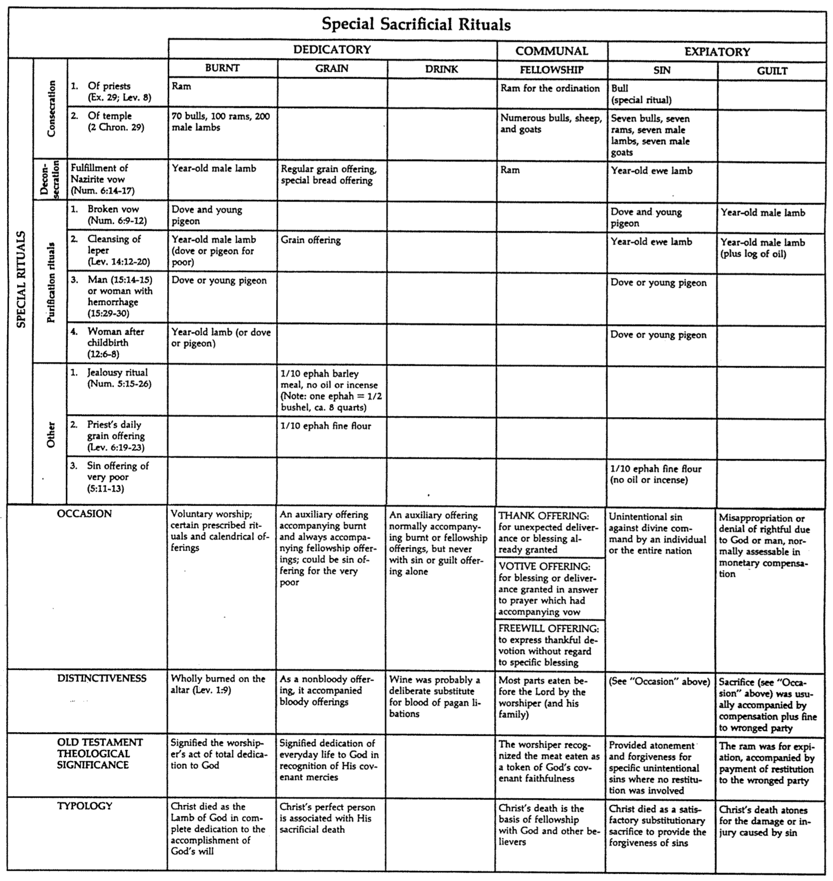

Why No Pork? (And Other Law Questions)

Egyptian doctors of Moses’ time treated wood splinters in the skin with worm’s blood and donkey dung. “Since dung is loaded with tetanus spores, it is little wonder that lockjaw took a heavy toll of splinter cases” (S. I. McMillen, None of These Diseases [Old Tappan, NJ: Revell, 1963], 9).

God gave many commands to Israel through Moses without explaining the reasons for them. Only in modern times have some of these reasons come to light. Yet he did promise Moses, “If you listen carefully to the voice of the LORD your God and do what is right in his eyes, if you pay attention to his commands and keep all his decrees, I will not bring on you any of the diseases I brought on the Egyptians, for I am the LORD, who heals you” (Exod. 15:26). Here are some examples:

Issue | Law Command | Reason
Why not eat pork, bacon, or ham? | “And the pig, though it has a split hoof completely divided, does not chew the cud; it is unclean for you. You must not eat their meat or touch their carcasses; they are unclean for you” (Lev. 11:7-8). | “The vast majority of the foods prohibited are those which (1) are more likely to carry disease in the arid climate of the Sinai desert and/or… Canaan; or (2) are… uneconomical to raise as food in the particular agrarian context…; or (3) are foods favored for religious sacrifice by groups whose practices the Israelites were not to copy… the food laws… kept Israel away from certain allergies [but] the main source of Israel’s meat–lamb–is the least allergic of all major meats” (Fee & Stuart, How to Read the Bible for All Its Worth, 145).
Why require circumcision? | “You are to undergo circumcision, and it will be the sign of the covenant between me and you. For the generations to come every male among you who is eight days old must be circumcised, including those born in your household or bought with money from a foreigner –those who are not your offspring” (Gen. 17:11-12). | Modern studies show that wives with circumcised husbands have far less cervical cancer than those with uncircumcised husbands. Non-Jewesses are 8 times more likely to have cervical cancer than Jewesses are since uncircumcised men can deposit cancer-producing Smegma bacillus bacteria in the uterus (McMillen, 17-19). Also, the eighth day of a boy’s life has the highest levels of vitamin K and Prothrombin for blood clotting (ibid, 20-21)!
What’s wrong with mixing meat and milk? | “Do not cook a young goat in its mother’s milk” (Deut. 14:21). | God prohibited this because: (1) it would have been engaging in the fertility cult practices of Canaanites (Fee & Stuart, 146) or (2) because calcium cannot be assimilated easily on a milk and meat diet, which weakens teeth and slows the healing of broken bones (US News & World Report, 28 May 1984).
“Lepers feel bad enough about their disease, so why isolate them?” | “The priest is to examine the sore on his skin… If the spot on his skin is white but does not appear to be more than skin deep and the hair in it has not turned white, the priest is to put the infected person in isolation for seven days … As long as he has the infection he remains unclean. He must live alone; he must live outside the camp” (Lev. 13:3-4, 46). | Between the 6th-14th centuries leprosy killed hundreds of millions of Europeans. Some said this was because of eating hot food, pepper, garlic, or the meat of diseased hogs–or even a bad conjunction of the planets! The Black Death followed, killing 60 million ( of Europe). After the physicians had nearly given up, the Church suggested the scriptural quarantine of lepers, which finally stopped the dreadful plague (McMillen, 11-12).

Contrasting Levites and Priests

 | Levites | Priests
Descendants of… | Levi | Aaron (also a descendant of Levi)
Population | Many (the larger group) | Few (a subset of the Levites, Josh. 21:4)
Role | Assisted priests (1 Chron. 23:28) and supervised religious activities permitted outside of the sanctuary: teaching (Deut. 33:10a), singing (1 Chron. 15:16-24), leading worship (1 Chron 16:4-6; 23:5), officials, administration, judges & gatekeepers (1 Chron. 23:4-5) | Mediators between God and Israel whom David made into 24 divisions (1 Chron. 24:3-4), each which served two weeks annually so that their service would gradually move around the calendar (BKC, 1:613); taught God’s Word (Mal. 2:7)
Sacrificial Role | Didn’t offer sacrifices though they did offer incense (Deut. 33:10b) | Offered sacrifices (Deut. 33:10b)
Location of Homes | Extensive–in 35 cities throughout the tribes in the central, northern, and eastern parts of Israel (Josh. 21:5-8) | Limited to 13 cities in the southern territories of Judah, Simeon, and Benjamin which were near the temple (Josh. 21:4, 9-13)

Abraham

Isaac

Jacob

Reuben–Simeon–Levi–Judah– etc. (12 sons of Jacob)

All other lines Aaron

Levites Priests
see OTS, 171a see OTS, 202

Old Testament Feasts and Other Sacred Days

The Bible Visual Resource Book, 31

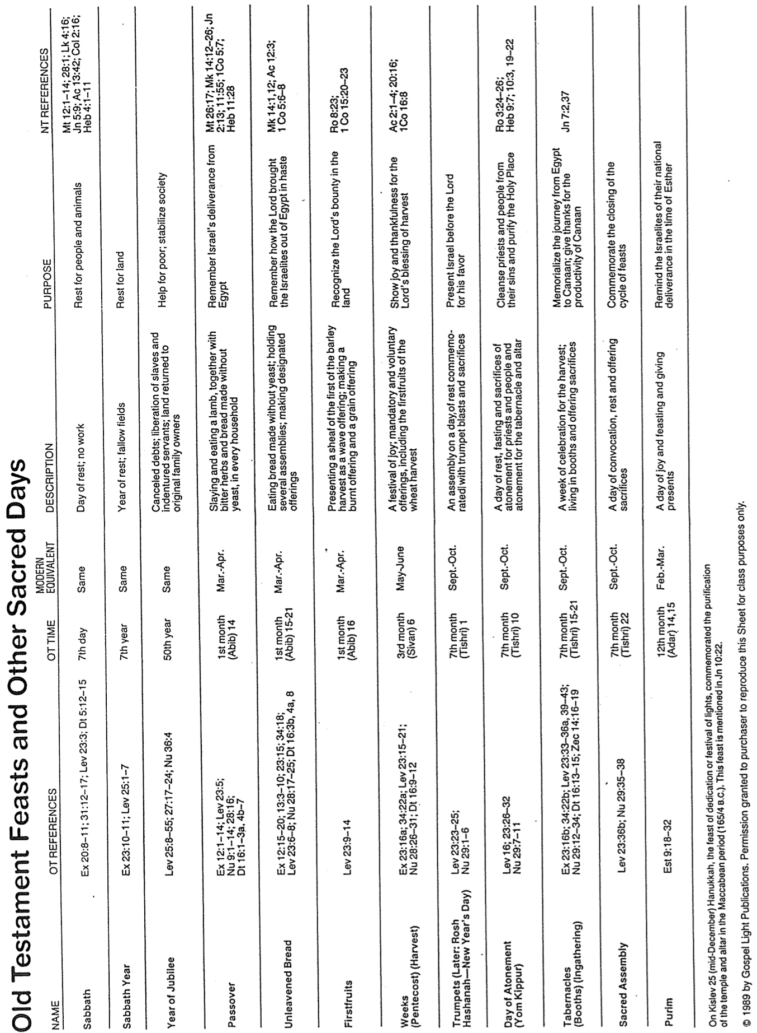

Eschatology of Israel’s Feasts (Lev. 23)

 | Date | Length |  | Feast | Significance (Past) | Typology (Future)
1. | Weekly | 1 day |  | Sabbath*  (Shabbat) | Reminder of:  • Creation rest of God  • Deliverance from Egypt  Sign of Mosaic Covenant  (Exod. 20, 31; Deut 5) | Millennial rest  (Heb. 4:1-11)
2. | 1-14  (Nisan) | 1 day  (Read Song  of Songs) |  | Passover*†  (Pesach) | Redemption from Egypt by blood of the sacrificial lamb (Exod. 12) | Redemption from sin by Christ's death as Lamb  (1 Cor. 5:7b)
3. | 1-15  to 1-21  (Nisan) | 7 days |  | Unleavened  Bread*† | Separation/break from dependence upon Egypt to dependence upon God | Separated life of the redeemed for God  (1 Cor. 5:7a, 8)
4. | 1-16  (Day after Harvest Sabbath) | 1 day |  | Firstfruits  (barley sheaf ceremony) | Anticipation of God's future material provisions  -begins grain harvest | Resurrection of Christ  (1 Cor. 15:20)
5. | 3-6  (Sivan) | 1 day  (Read Ruth) |  | Pentecost†  (Shavuoth)  (Weeks)  (Harvest) | Thanksgiving for God's past material provisions  -ends grain harvest (Deut. 16:9-12) | Coming of the Holy Spirit to complete Christ's resurrection (Acts 2)
– | Spring-Summer | no feasts |  | – | Enjoyment of the harvest | Church Age
6. | 7-1  (Tishri) | 1 day |  | Trumpets  (New Year)  (Rosh Hashanah) | Preparation for national redemption and cleansing on Day of Atonement | Rapture (1 Thess. 4:13f.) Revelation (Matt. 24:31)  –Kingdom preparation
7. | 7-10  (Tishri) | 1 day |  | Day of Atonement (Yom Kippur) | National repentance and cleansing from sins of the people (Lev. 16) | National repentance of Israel in the Tribulation (Rom. 11:26-27)
8. | 7-15  to 7-21  (Tishri) | 7 days  (Read  Eccles.) | Tabernacles*†  (Booths/Tents)  (Succoth)  (the Lord)  (Ingathering) |  | Anticipated fulfillment of the Abrahamic Covenant (Neh. 8) | Actual fulfillment of the Abrahamic Covenant  –Kingdom (Matt. 17:4)
9. | 7-22  (Tishri) | 1 day | Shemini Atzeret  (Simchat Torah) |  | “8th Day of Assembly” “Rejoicing in the Torah”
The following days are not commanded in Scripture and probably have no eschatological significance:
10. | 5-9  (Ab) | 1 day  (Read Lam.) |  | 9th of Ab  (Tish’ah be’ab) | Destructions of Jerusalem:  586 BC & AD 70 | ↑
11. | 9-25  (Kislev) | 1 day  + 7 more days of candle lighting |  | Hanukkah  (Dedication)  (Lights)  (Illumination)  (Maccabees) | Saving of the nation  under Judas Maccabeus  in 164 BC  (cf. John 10:22) | This Typology column shows that the order of Israel’s annual feasts prophetically parallels her experience as a nation throughout history!
12. | 12-14/15  (Adar) | 2 days  (Read Esther) |  | Purim  (Lots) | Saving of the nation  under Esther (9:21)

* Feasts celebrated in the Millennium (Isa. 66:23; Ezek. 45:21; 46:1; Zech. 14:16-19)
† Feasts celebrated in three annual Jerusalem pilgrimages by all male Israelites (Exod. 23:14-17)

Leviticus & Numbers Contrasted

Huang Sabin, OT Made Simple

